OAKLAND PUBLIC SCHOOLS
OAKLAND, NEW JERSEY

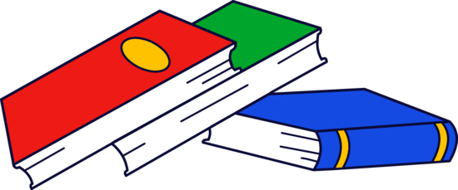
Raz-Kids
January, 2014

Dear Parent,

I am very excited to inform you that our classroom is piloting a new program called
Raz-Kids by Learning A-Z. It is a program that gives students access to hundreds of animated, leveled books on students’ independent level. Additionally, children will have the ability to read books from a home computer, record their voices, and take a quick quiz to ensure that they understood the selection.

Attached please find the website’s address and your child’s password. The letter also explains how you can support your child’s progress with the program. Continued implementation of the program across the district will be dependent upon the feedback from students, parents, and teachers.

Please do not hesitate to contact me if you should have any questions or concerns.

Sincerely,

(Teacher’s Name)

